MC900389546[1]

**St Mary & All Saints Church.**

**Fillongley**

***CHRISTMAS TREE FESTIVAL***

***2015***

**Friday 27th November ~ Sunday 29th November**

**FRIDAY**

6:30pm. Grand Opening by Mrs Alison Patchett, Headteacher of Bournebrook School,

with singing by the School Choir, Christmas Tree viewing and special visit by REVERSE Father Christmas, who will receive your gifts to be sent to less fortunate children in the local area

**SATURDAY**

10am –5pm. Christmas Tree Festival viewing,

including Turkey batches & punch, tea & coffee, cakes & biscuits.

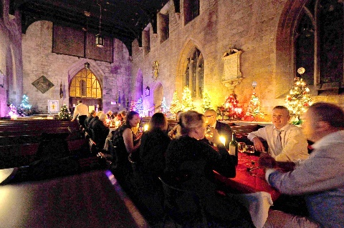7:15 for 7:30pm Christmas Tree Festival Banquet.

**Guests enjoying the 2014 Banquet.**

*Entry strictly by ticket only, purchased in advance of the evening from John 0’Brien (01676 541409) or Revd Ian Kennedy (01676 540320)*

**SUNDAY**

11am – 5pm. Christmas Tree Festival viewing.

7:15 for 7:30pm. Christmas Tree Festival Banquet.

*Entry strictly by ticket only, purchased in advance of the evening from John 0’Brien (01676 541409) or Revd Ian Kennedy (01676 540320)*