League Football
Wednesday 11th November 2015
We played our next round of league games at Park Lane school.
Our first game was against All Saints and we started really well passing the ball and creating chances to be rewarded with a goal from James and then a goal from Josh M. All Saints made changes at half time and came back at us. I don’t know if we just sat back on the 2 – 0 lead but in quick succession our opposition netted 2 goals which, despite our best efforts, we couldn’t reply to and the game ended with a 2 – 2 draw in a match we should have won!
Our second game of the evening was against Twycross and we just weren’t the team from the first game. Twycross had much of the play in the first half and our defenders played really well and kept them at bay until eventually they broke through and scored. Despite our best efforts we only created a few chances and the game ended with a 3 – 0 loss – our first loss of the season. Respect to our opposition, they played well and went on to win both their games during the evening.
Despite the loss we played well as a team, our passing is improving all the time. Well done team and thanks once again to all the parents for your continued support.
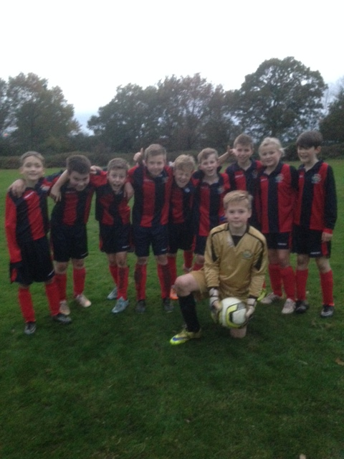
We have a winter break from football now until our next round of fixtures on 2nd March.

