ROWING COMPETITION RESULTS
SCHOOL GAMES COUNTY FINALS 2016

 | 4 min  Relay  (1 min) |  | Individual  1min 30sec
Joe |  |  | (347) 348
Bartek |  |  | (334) 354
Josh |  |  | (310) 320
Caleb |  |  | (333) 349
 | 926m | Previous record 833  899 | (previousPB)
Katie |  |  | (260) 305
Isobel |  |  | (292) 316
Millie |  |  | (288) 306
Jess |  |  | (322) 334
 | 842 | 814

Absolutely incredible! Our rowing teams competed in the School Games level 3 county finals in Rugby; the culmination of all the hours practising totally paid off as every single one of them smashed personal records and the relays once again broke all Bournebrook records with a phenomenal 926 metres in 4 minutes from the boys' team (previous record 899). I cannot express how proud I was of this team as results were announced and the boys came 2nd place against schools from Warwickshire, Coventry and Solihull, such an incredible achievement once again for our small school!
Silver medal winners...go team Bournebrook! In fact the whole team – mixed girls and boys - raced an 8 minute relay (30 seconds each with 2 changeovers) and came 2nd place!

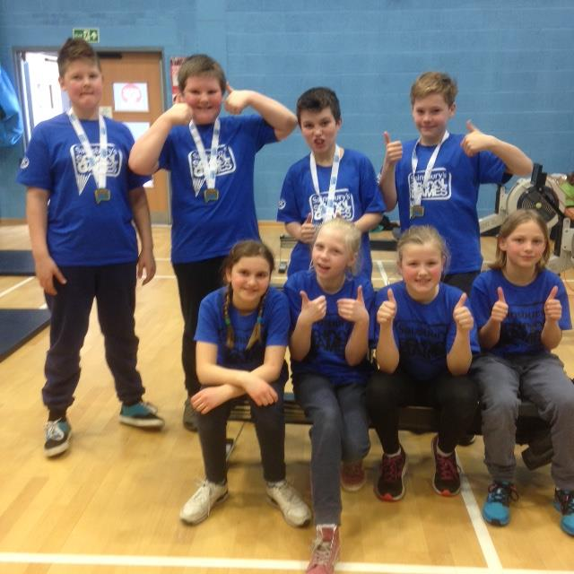
Our silver medal County final rowing teams!
