Sports at Bournebrook 2014 / 15
Another fantastic year of sport this year with an abundance of successes in a wide variety of sports. All of our children have competed in sports competition against other schools and progression to level 3 county finals has once again been exceptional for a small school such as Bournebrook!
This year also saw more competition within school with football, netball, gymnastics, dance and cricket being played amongst our houses
We also had cause to celebrate with Mrs Cove being a finalist for PE Teacher of the Year for Coventry, Solihull and Warwickshire after being nominated and then shortlisted to top 3 in the county.
Athletics
YEAR 5/6
We entered the Indoor Athletics Local heats at Ash Green school and despite a breath-taking relay finish by both our girls team and boys we only managed 4th place this year and didn’t progress to finals.

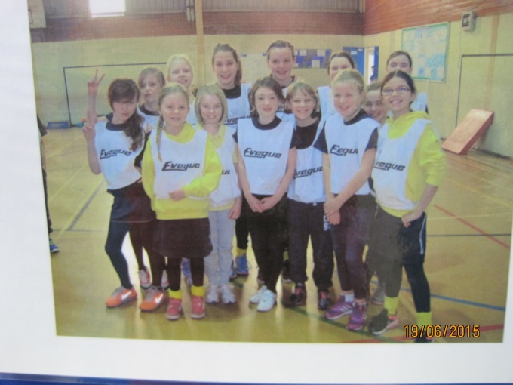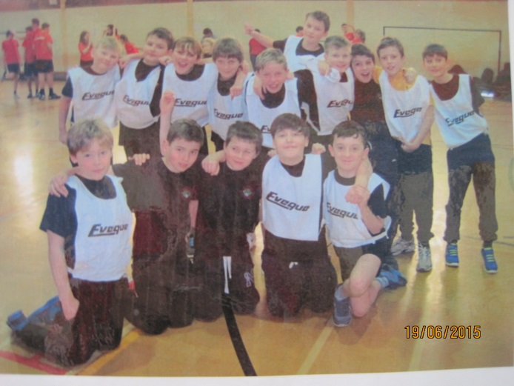

YEAR 3/4
Our year 3 /4 children (boys team and girls team) took part in the Quad kids competition and won the local heat at Queen Elizabeth School against 4 other schools. Another great achievement for our school! They then went on to area finals at the Pingles in June where they came 3rd place out of 6 schools, only missing out on silver medals by 8 points!

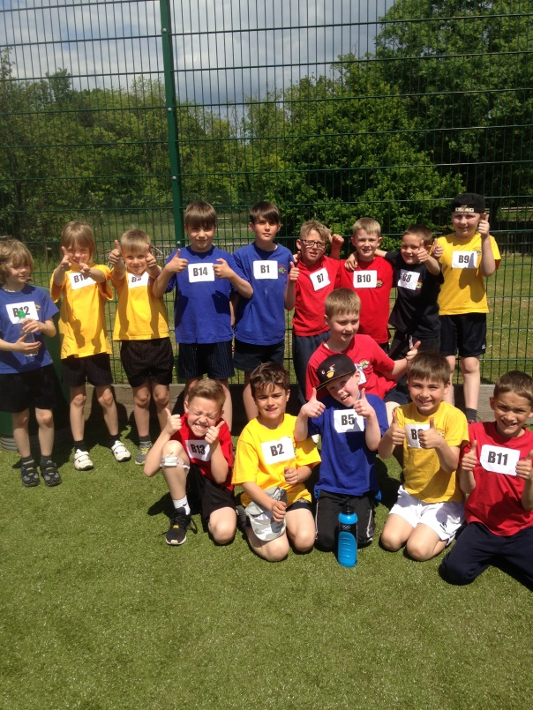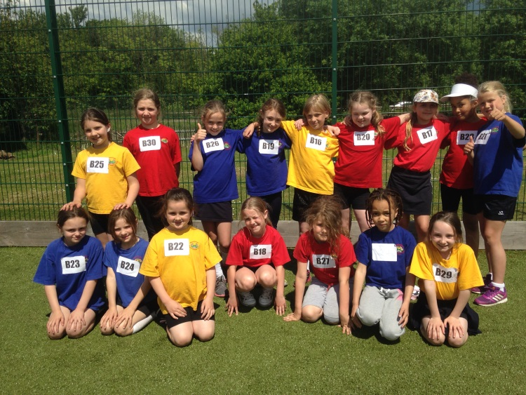

YEAR 1/2
In the summer our younger children took part in the Infant Athletics at Queen Elizabeth School. The children really enjoyed the morning of sport and our A team came a brilliant 1st place and our B team 2nd! They progressed to the area finals where we were very proud when they came 2nd place!

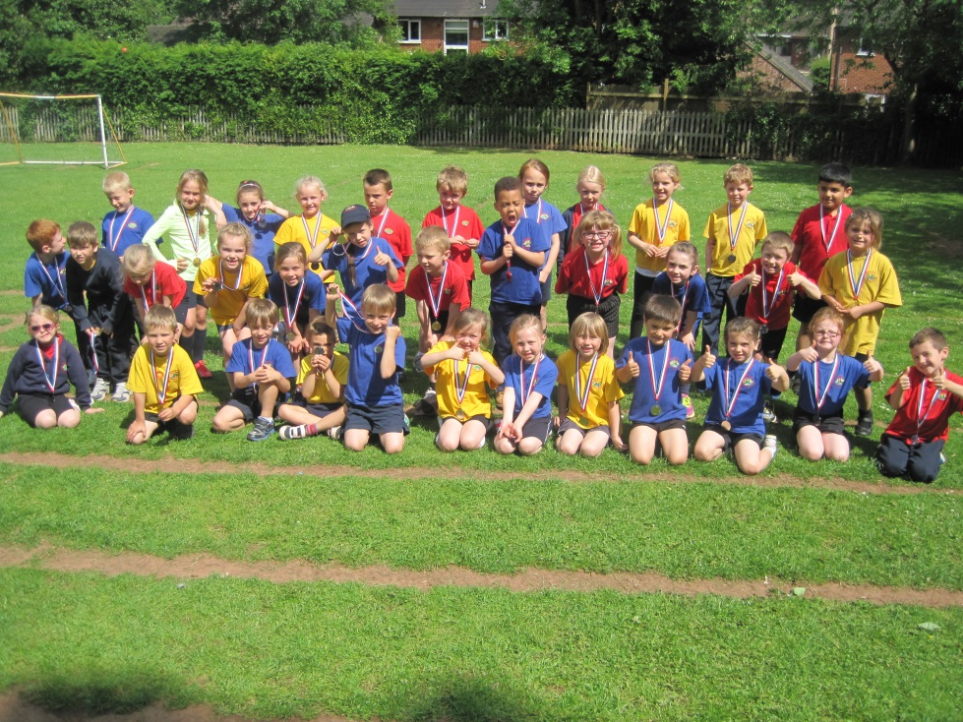

FOOTBALL

YEAR 5/6 LEAGUE
Our Year 6 team played in the Nuneaton League , however despite some good results we had to give the trophy to Queens Academy and be content with 2nd place this year! We will be fighting to win it back next season!

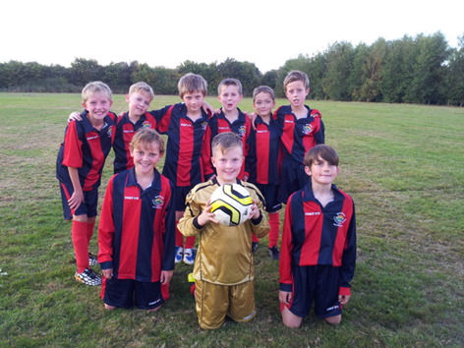

In January, we also played in the County Finals at Baddesley. Despite losing, we all enjoyed the afternoon and were proud to be representing our area in the County Final for the second year in a row.

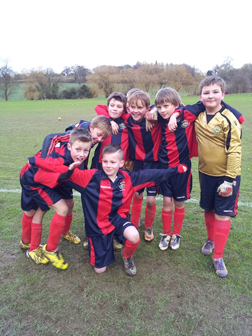

YEAR 5 TOURNAMENT
We once again played in the tournament at Milby where despite winning our first game we unfortunately didn’t make it to the finals for next year.

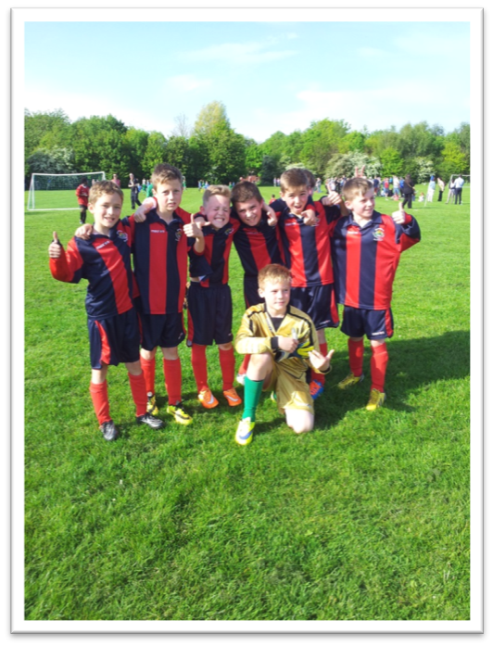

Year 3/4 football
Our younger footballers had the chance to compete in the annual tournament at Nuneaton Academy where they managed to win a couple of games but this wasn’t enough to progress to the finals.
They also played in a tournament for small schools and despite not losing a game and not letting a goal be scored against us the three 0 – 0 draws meant we came 3rd place.
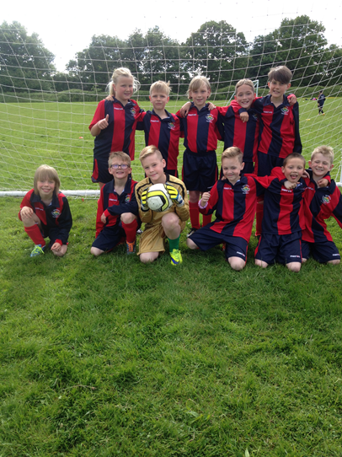

Girls’ Football
Increased participation in girls’ football this year meant we were really confident entering the annual tournament at Nuneaton Academy where our team reached the semi-finals only to lose out on a finals place by a penalty shoot-out! Our girls also played in friendly games against local schools.
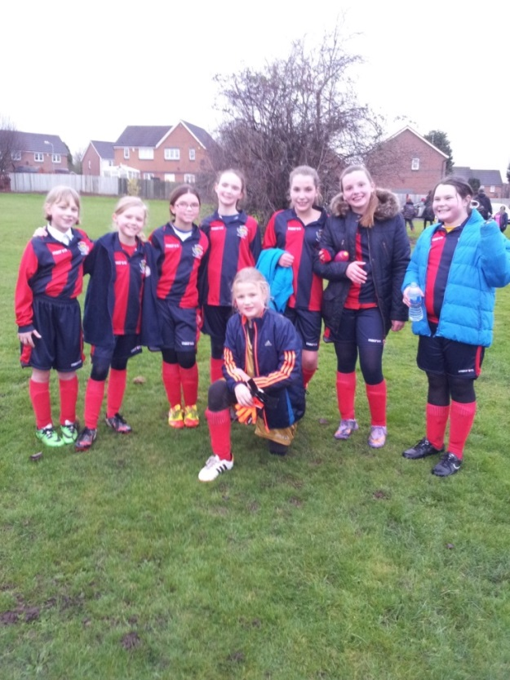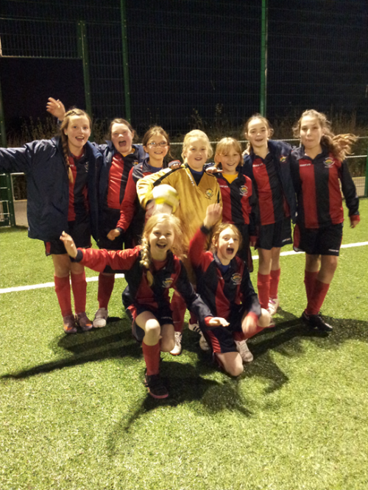

Winners of the inter – house football tournament were YELLOW team.

TAG RUGBY
With much thanks to parent volunteer Mr Lawrence, we managed to coach a rugby team again this year and we entered a Tag Rugby tournament at the Old Edwardians Rugby Ground, Nuneaton, where we played some good rugby and managed to win a game in a very tough competition. The future looks good for Tag Rugby at Bournebrook!
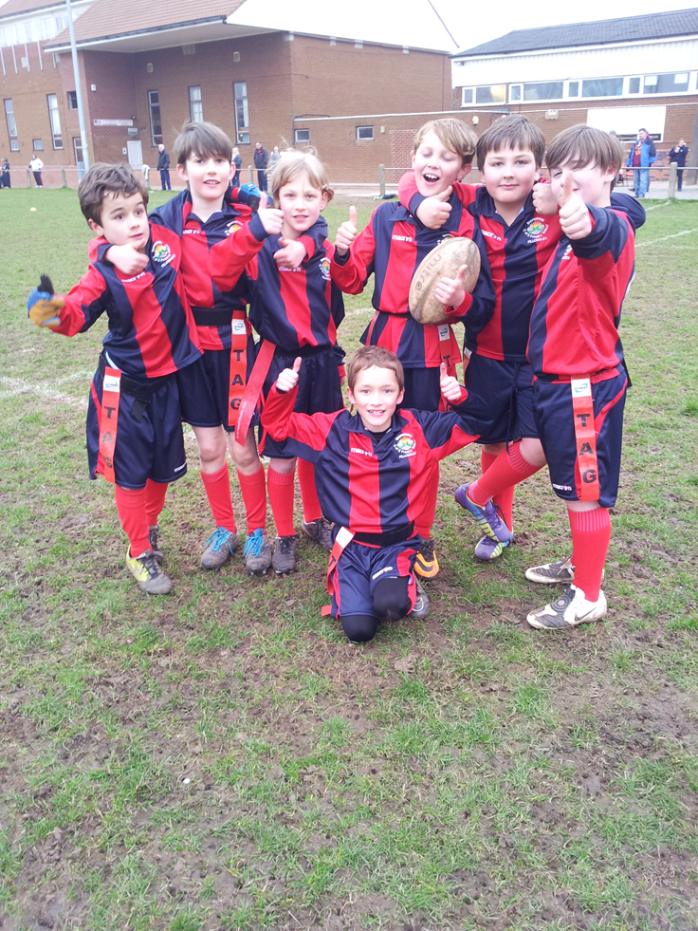

NETBALL
Due to our success in netball competition last year we had increased numbers for our after school club and with the continued coaching expertise of Lindsey Acton we had enough players for more than 1 team this year!

YEAR 5/6
Our team played a total of 8 games in the Nuneaton Schools year 6 league and finished 7th place despite playing some great netball and winning some of their games .
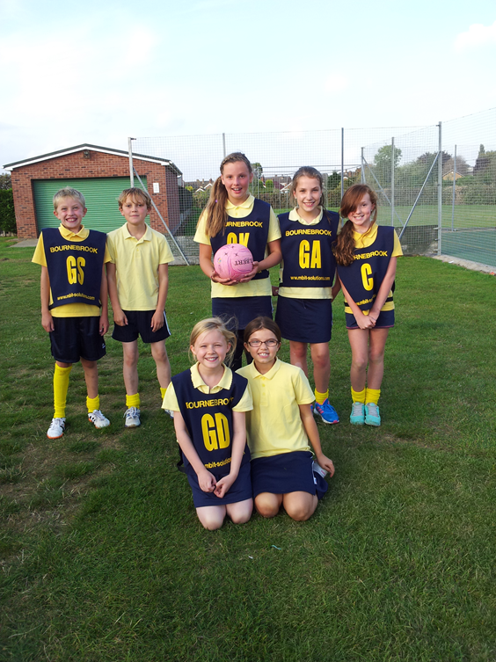
The team also played in a year 6 tournament
With the great reputation they had gained we were once again invited to Twycross to play in a 7 a-side tournament.

YEAR 5 A Team and Year 4 B Team
Our younger teams played in the Nuneaton Schools year 5 league and we were really proud that they won silver and bronze medals for finishing in 2nd and 3rd place in an extremely competitive competition.
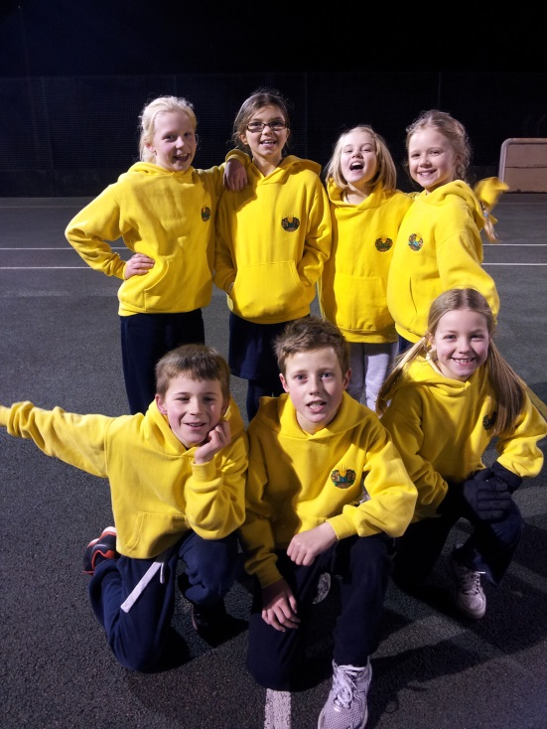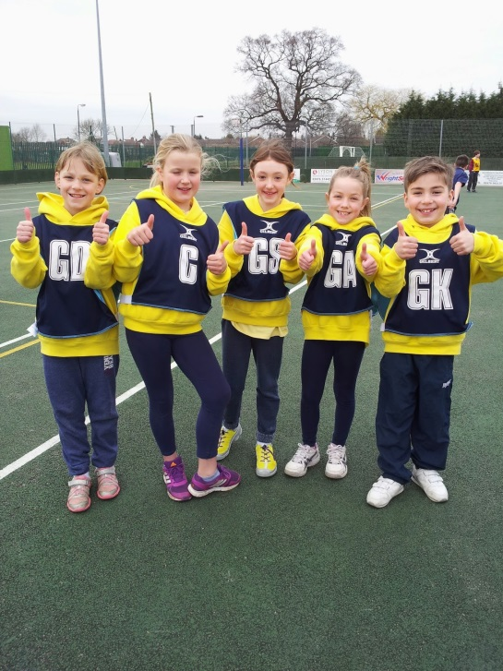
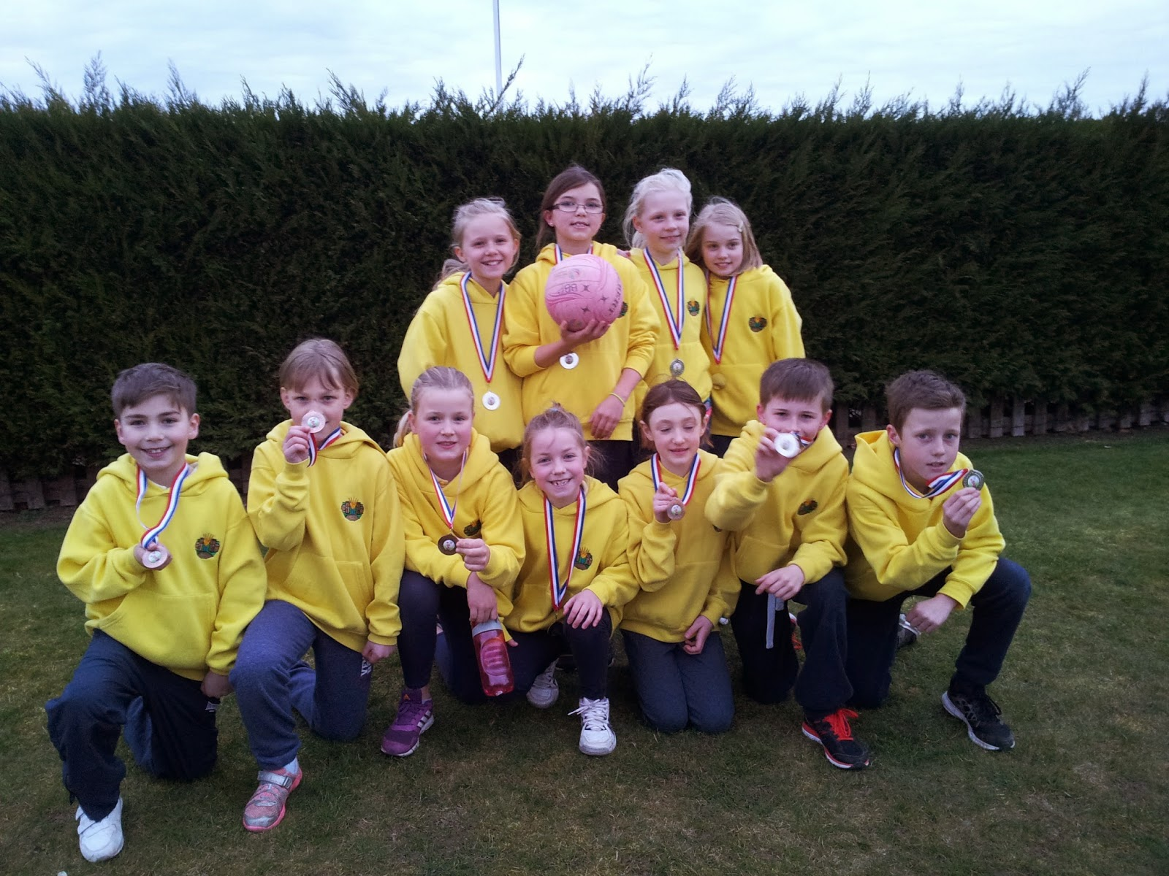

We also had the opportunity to play in a netball festival at Bablake school as part of school sport links. The team had a fun and rewarding time and the 1 – 0 win was a great way to end the afternoon of netball!

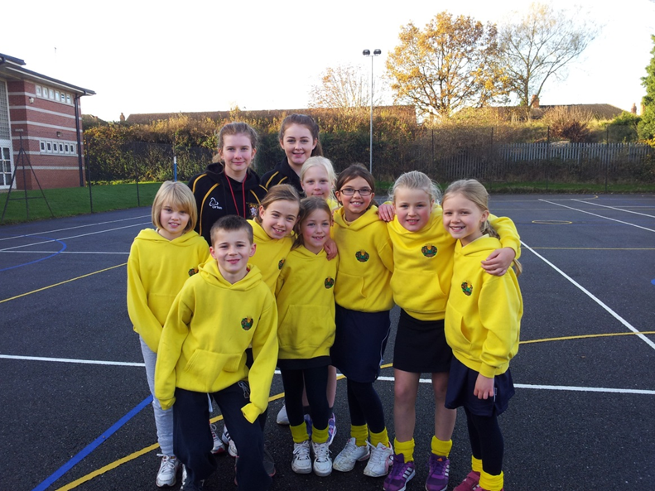

The success of our netball teams has been down to the commitment and efforts of our volunteer parent Mrs Acton.

Our inter – house netball tournament was won by BLUE team
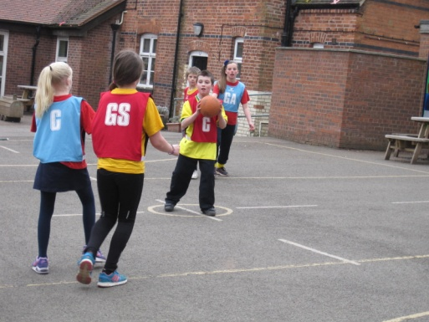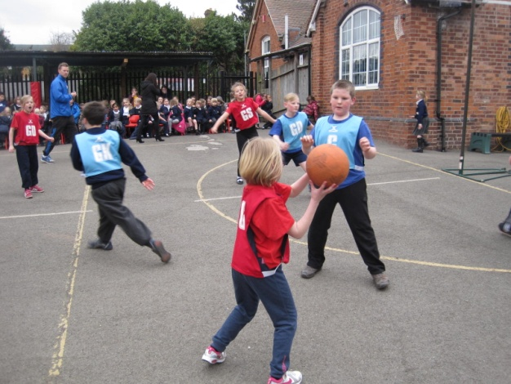

ROWING
In December our team of girls and boys went to Etone to compete in the annual rowing competition. Expectation was high following on from the success of our rowers last year. We had been practising hard on our new acquisition of our own rowing machine and we were ready.
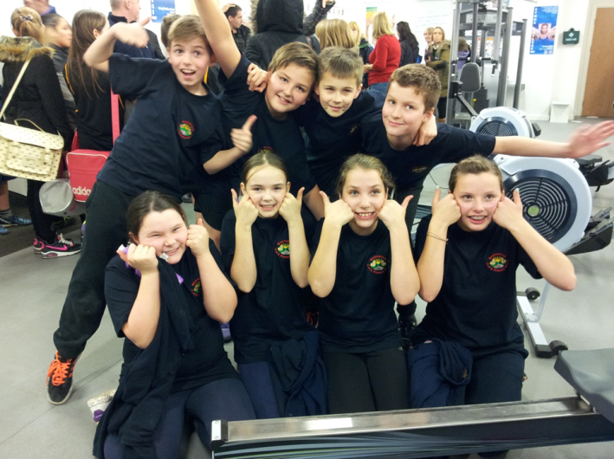
Once again this was probably one of the most exciting afternoons of sport as our teams rowed against other schools and made us so proud . The opposition was great but our boys came 2nd place and our girls team once again came 1st place and were through to the level 3 winter school games!! Our teams rowed so well they rowed the other schools off the board – literally!
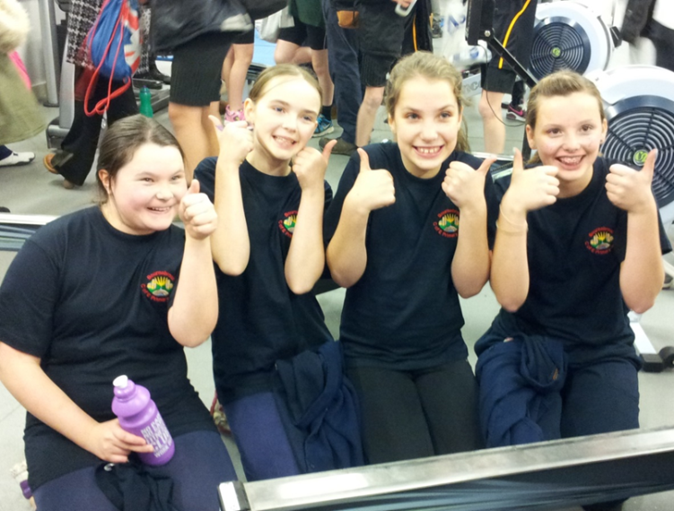
Our winning rowing team
The level 3 games was an exciting day out in Coventry for our rowers and despite smashing our scores from the heats our girls finished in 4th place .However we were not disappointed and are looking forward to competing in this sport again next year!

CROSS COUNTRY
We entered a couple of races in the autumn term and all of our children completed the course well within the final positions.

CRICKET
Thanks to Corley Cricket Club who came during the summer term to run our after school cricket club and prepare a team for a Kwik Cricket competition. The standard was really high in the competition but we gave it our all and after winning 2 games and losing 2 games we finished a respectable 3rd place against large schools from across Warwickshire!
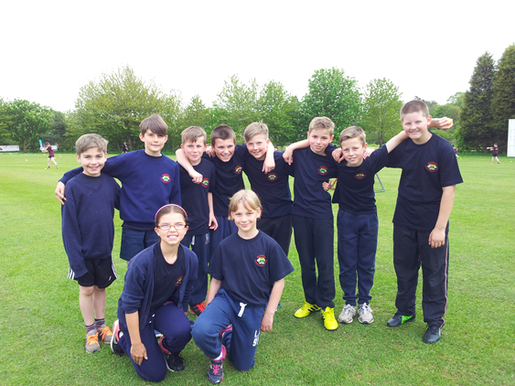

We would also like to thank Fillongley Cricket club for sharing their coaching expertise with our younger children.

DANCE
We were really pleased to be able to offer a dance club this year and although we were disappointed when the festival at Bedworth Civic Hall was cancelled our dancers really enjoyed this opportunity and did show off some of their moves at the Fillongley Village Summer Fair.
We also held an inter – house dance festival, where our children were able to perform to each other. We had a variety of dances from each year group across the school from penguins, mood dance and a life cycle, to a Tudor dance, Mission Impossible and the Haka! We certainly have a talented bunch of dancers and BLUE team managed to impress the judges the most!
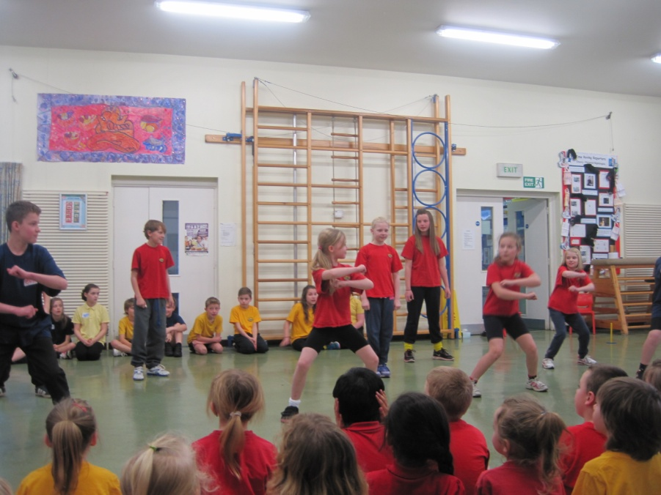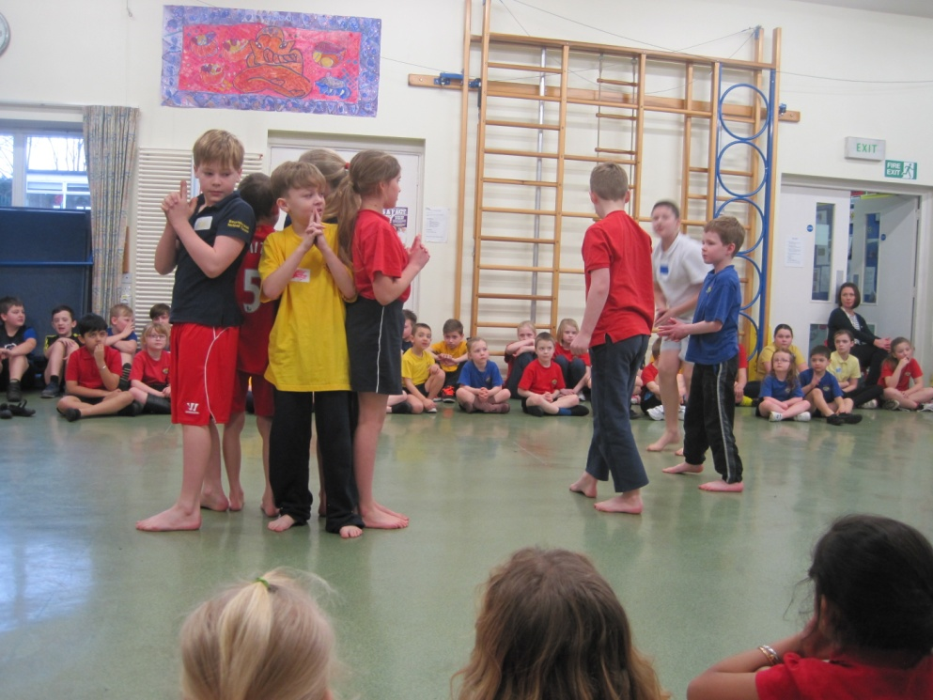

GYMNASTICS
Our inter – house gymnastics competition gave our children the opportunity to show what they had been learning in their PE lessons. RED team were the winners of this competition.
BIKEABILITY
11 of our Year 6 and 14 of our year 5 children completed their level 1 and level 2 courses to ensure they can ride their bikes confidently and safely.
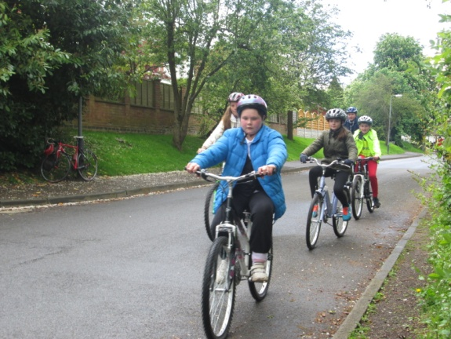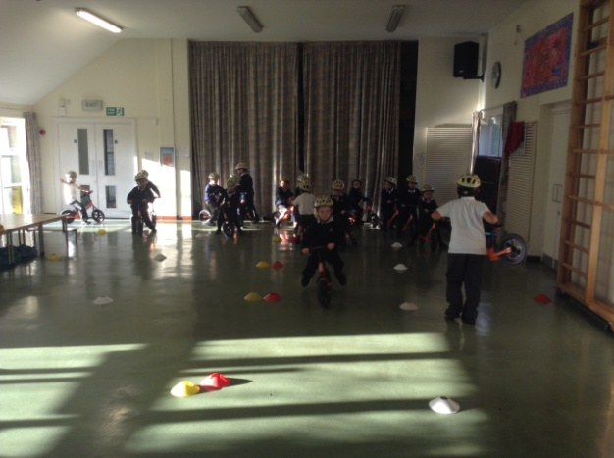
And our younger children practised their bike skills too.......

CHANGE FOR LIFE

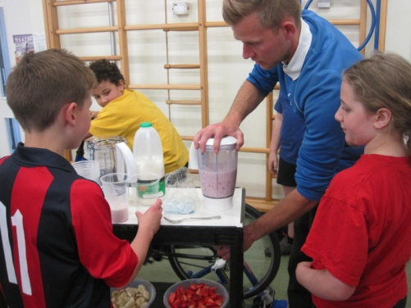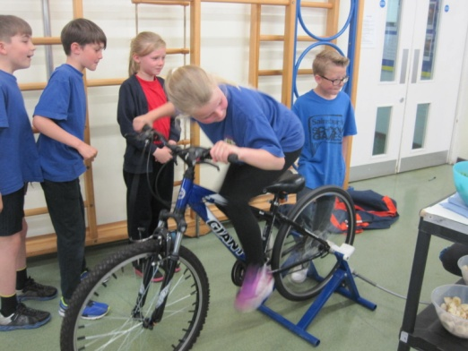

At Bournebrook we are committed to ensure we educate our children for an active and healthy life style and many of our children have attended our change for life club throughout the year. Every child also had the opportunity to work with Mr Leggett on a Change for Life programme of work.

Shugborough Residential for years 5 and 6
All of our year 6 children and most of our year 5 enjoyed a week away with Mrs Butler ,Mrs Perry and Mrs Cove to Shugborough Hall where they all enjoyed many activitites.

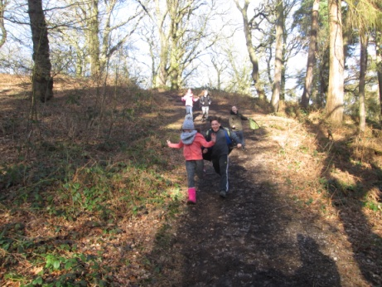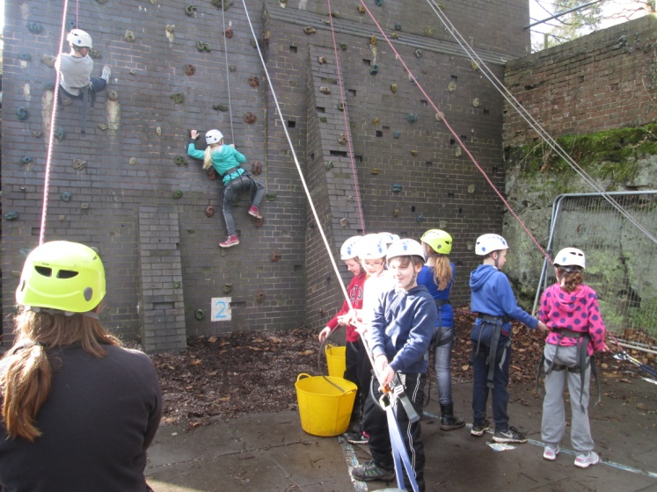
Chase walk Climbing
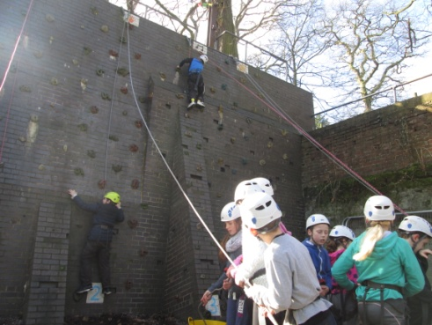
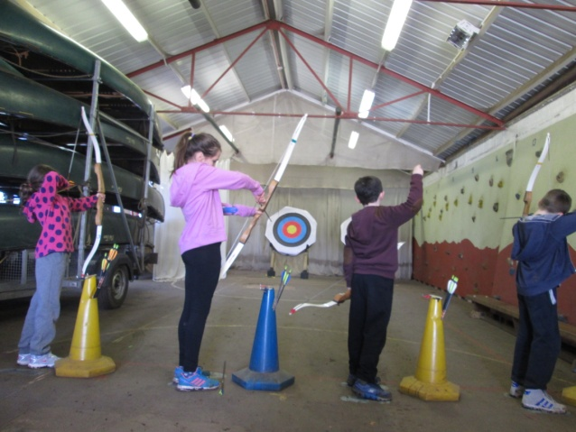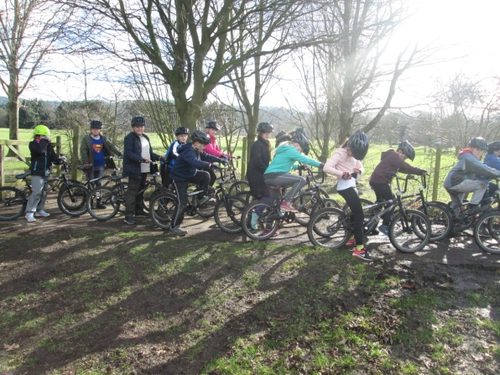
Archery BMX

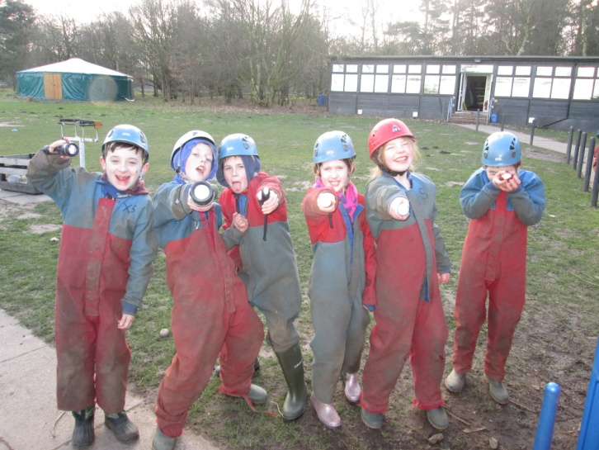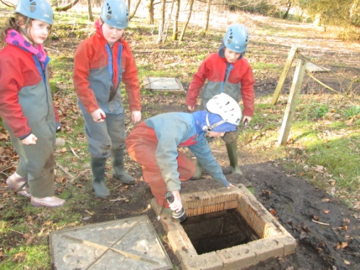

C
Caving

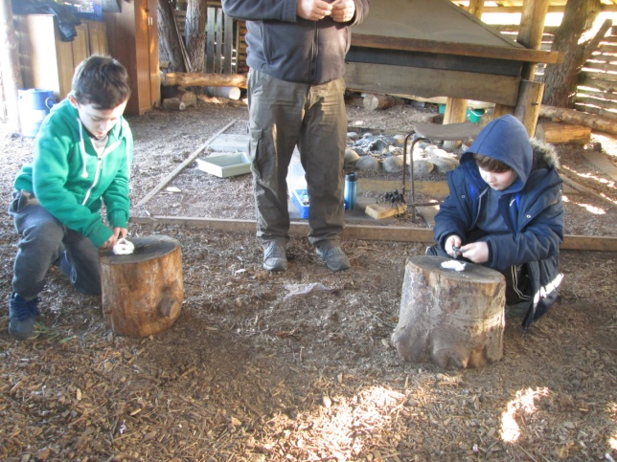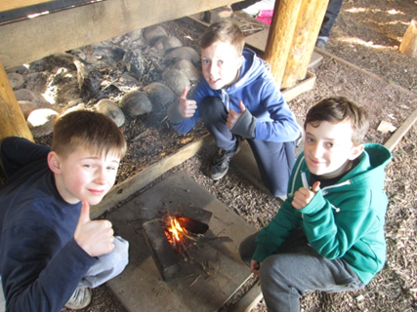
Fire lighting
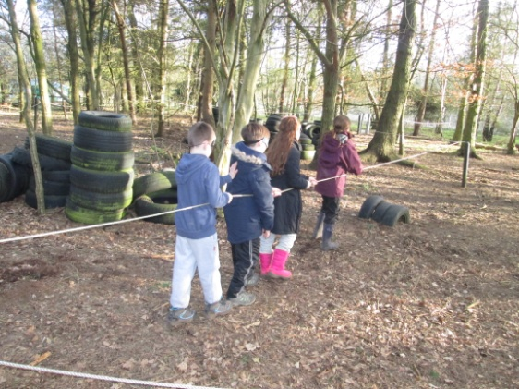 blind fold trail 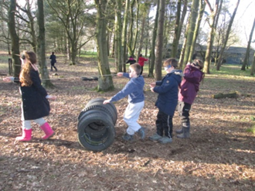

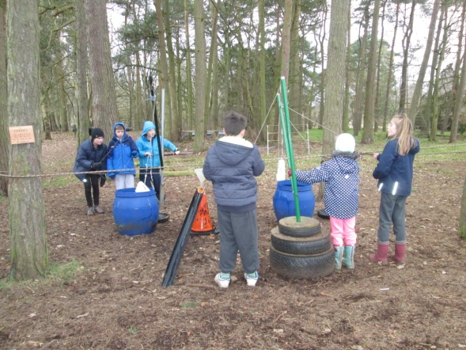 problem solving 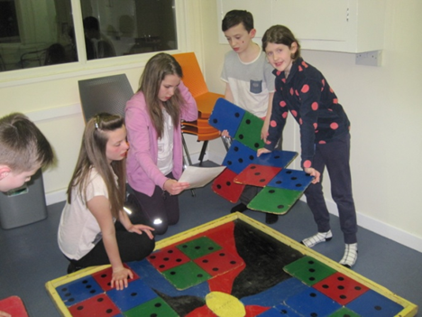
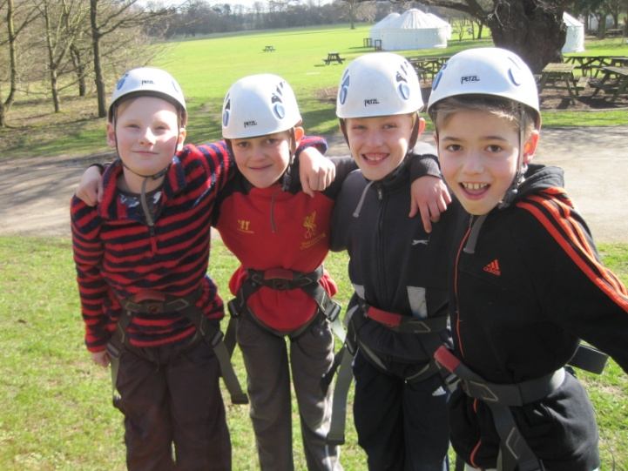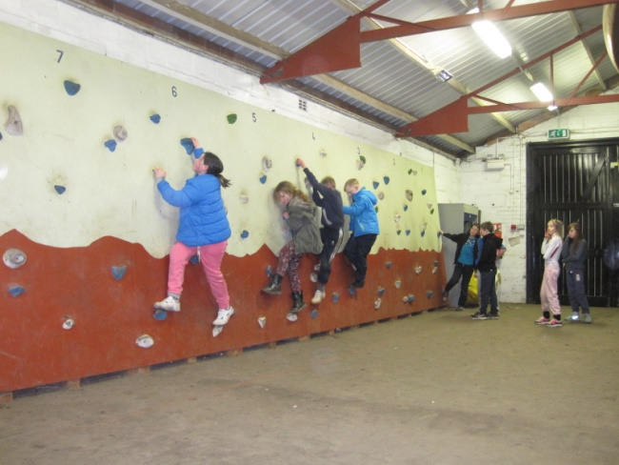
Wall climbing
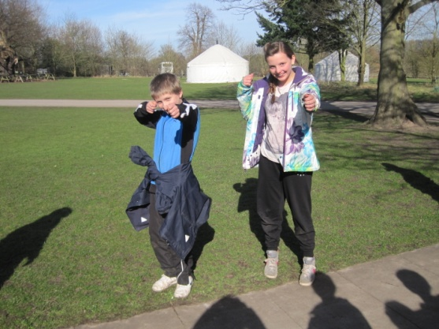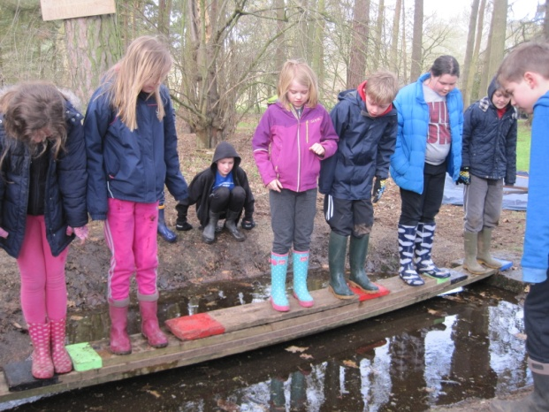
Archery experts bridge building
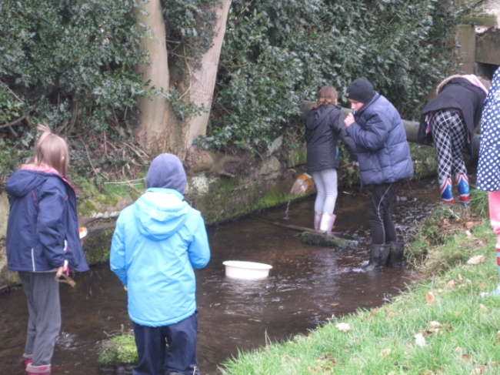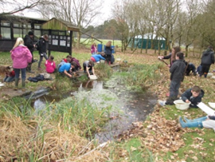
Pond and stream comparison

This is just a summary of all we have achieved in sport this year. More details can be found on the School Sports Pages on our web site, in our Extra Curricular Sport and Physical Exercise display folder and on our Sports Board outside the hall.

