Sports at Bournebrook 2015 / 16
After achieving the Sainsbury’s School Games GOLD award last year we were determined to work even harder in order to maintain this achievement for this year.
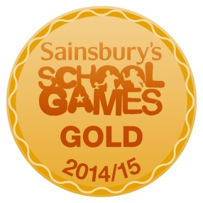
And what another fantastic year we have had. All of our children in years 3-6 have competed in sports competition against other schools and progression to level 3 county finals has once again been exceptional for a small school such as Bournebrook!
With our sports apprentice, Mr Mears, working hard with Sports Co-ordinator Mrs Cove, we have achieved so much this year...
Athletics
YEAR 5/6
We entered the Indoor Athletics local heats at Ash Green school and this year did better than last year and our team of girls and boys finished 2nd place and progressed to the finals!

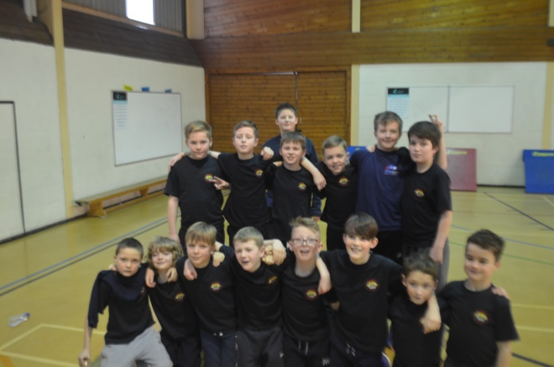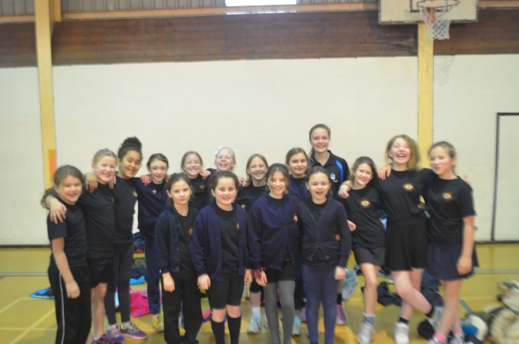

The finals were held at The Nuneaton Academy and we came 3rd place. Quite exceptional for our small school!

FOOTBALL

YEAR 5/6 LEAGUE

We played in the small schools league and finished 3rd place in a very close league campaign this year.

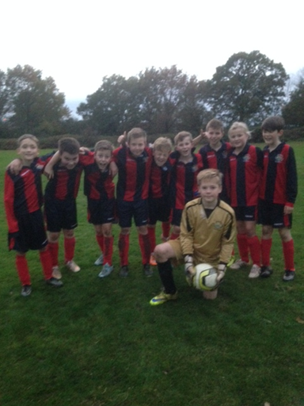

YEAR 5 TOURNAMENT
We once again played in the tournament at Milby where despite winning 2 games we unfortunately didn’t make it to the finals .

Girls’ Football
Increased participation in girls’ football once again meant we were really confident entering the annual tournament at Nuneaton Academy where our team failed to reach the final by a one goal difference and didn’t concede a single goal...that’s was unlucky! But the girls looked good sporting our new warm up tops kindly donated by Mr Jardim.
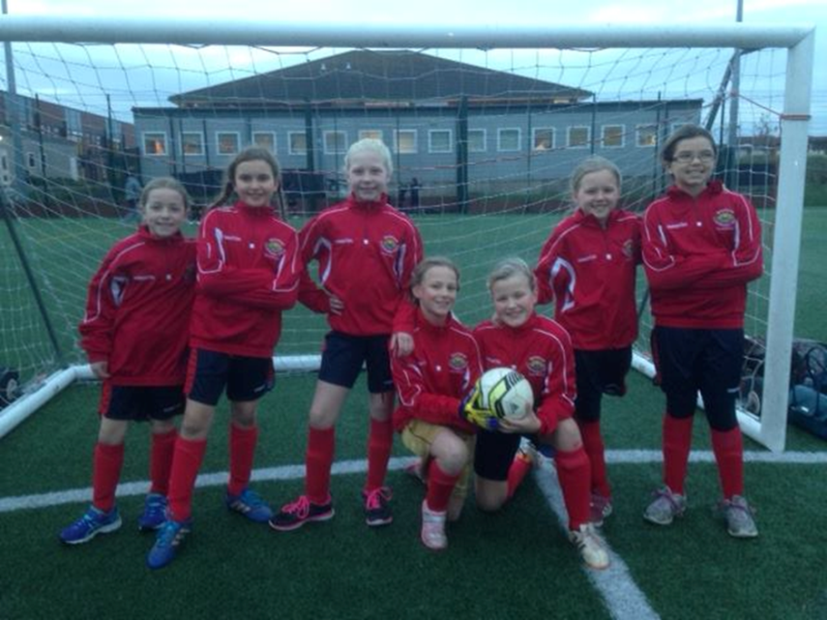

TAG RUGBY
With thanks once again to parent volunteer and Barker Butts coach Mr Lawrence, we managed to coach a rugby team again this year and we entered a Tag Rugby tournament at Keresley Rugby Club where we not only won the whole tournament but were also awarded the fair play trophy. Yes, we like to win, but to win showing true sportsmanship towards each other and our opposition is just fantastic!
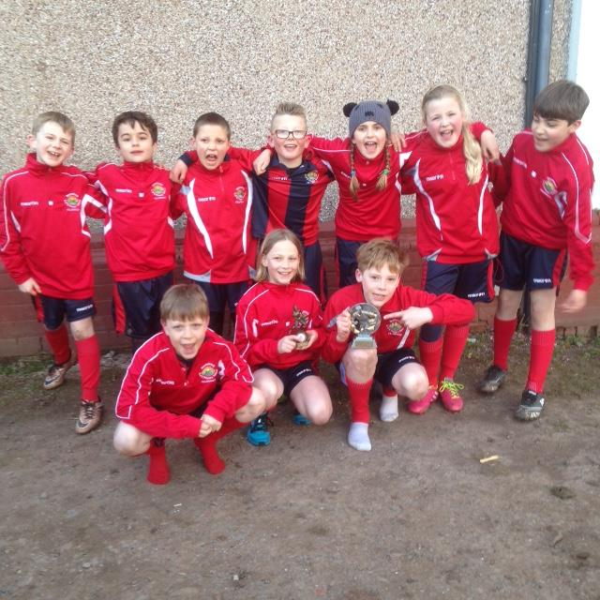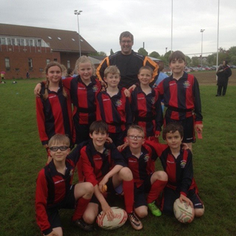
We also competed in the Nuneaton schools’ Tag tournament at the Old Eds Rugby Club and got some good results against top schools including a 6 – 5 win over St Joes! Our year 4/5 players did well winning 2 and losing 2 games against larger schools with all y6 players!

NETBALL
We once again were over subscribed to netball this year and managed to compete with both A and B teams in the Nuneaton Schools league. With the continued coaching expertise of Lindsey Acton we trained hard and while our year5/ 6 teams came in 4th and the B team 3rd. Both our year 4/5 teams came away with bronze medals finishing 3rd in the league. This was a fantastic achievement once again for our small school!
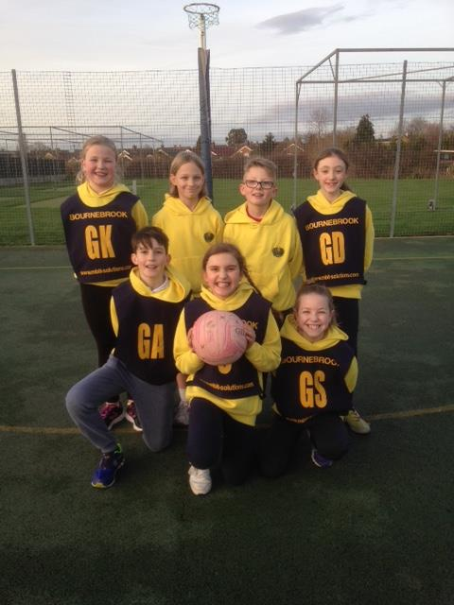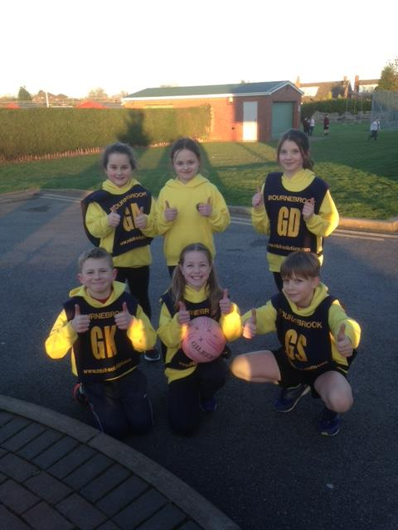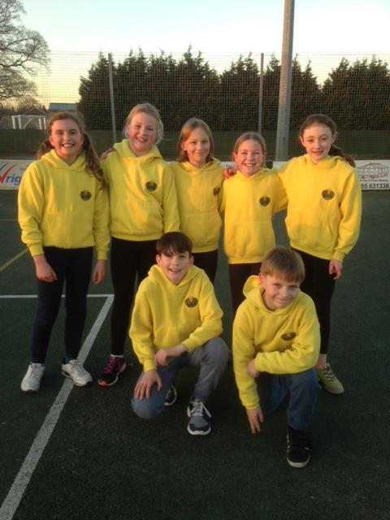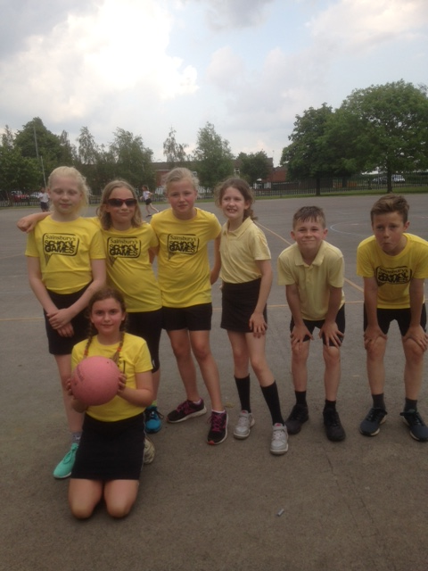
We also played in a small schools league where we won all our games except against 1 and this meant we finished 2nd in the league.

MODERN PENTATHLONN (BIATHLON)
Our teams of runners and swimmers won the Nuneaton Schools’ heats and progressed to County Finals! Words cannot be expressed to say how proud we were of our Biathlon team representing North Warwickshire in the county finals! Every single one of them gave it their all, running 400m around the track and then swimming 25m in the pool.
Just getting to the final was a massive achievement for our small school! However their efforts were rewarded as the boys came away with the bronze medals and our girls won the trophy for best team showing the 'values' of the school games. This meant they showed honesty, teamwork, respect, self-belief, passion and determination. What a wonderful thing for our children to be awarded!
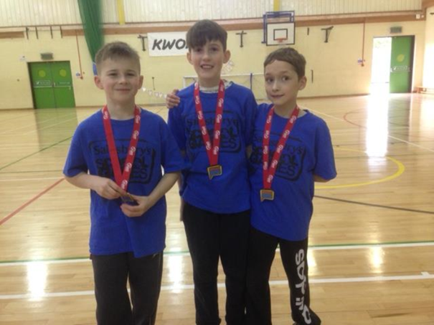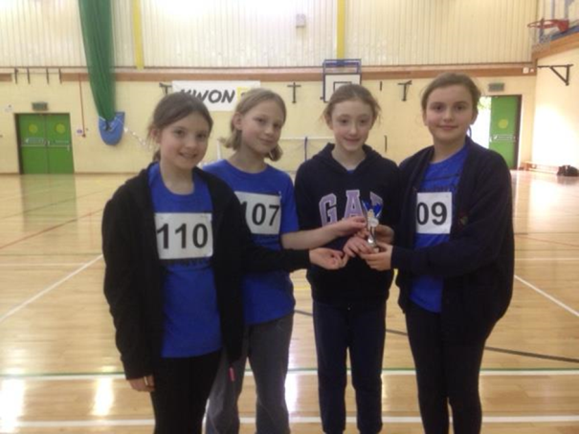

SWIMMING
We competed in the Nuneaton Schools swimming gala...we did so well against all the large schools this year coming 2nd place in the annual Nuneaton swimming gala! This meant we were chosen to represent Nuneaton in the North Warwickshire County Final. We are proud to say that our teams won and brought gold medals and a shiny cup back to Bournebrook. We have a very talented group of swimmers. Well done team! Great achievement once again for our small school!
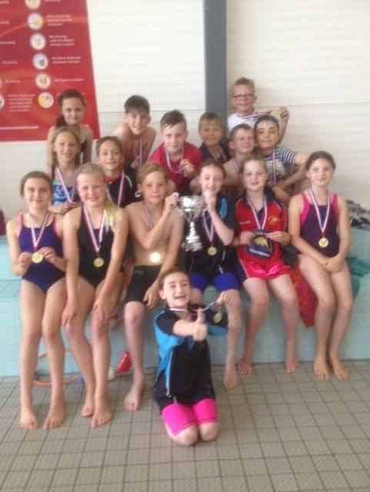

ROWING
In December our team of girls and boys went to Etone to compete in the annual rowing competition. We were very confident and the hard work paid off. Rowing has become highly popular in school and we managed to take both A and B teams the competition...Once again this was probably one of the most exciting afternoons of sport as our teams rowed against other schools and made us so proud . Our A teams finished in 1st place and progressed to the County Finals, with our boys’ team rowing the rest of the schools off the board- literally! Our B teams also did really well with the boys coming away with the silver medals!
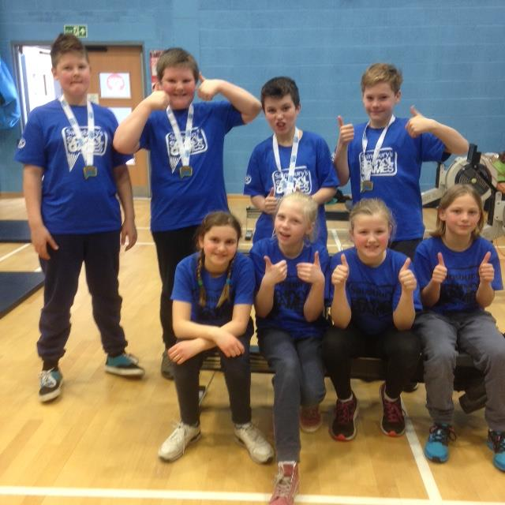
Our winning rowing team
The level 3 games was an exciting day out in Rugby for our rowers and both teams smashed personal bests. It was a very proud moment when it was announced our boys had finished in 2nd place – the second best rowers in Coventry, Solihull and Warwickshire! A phenomenal achievement!

CRICKET
Thanks to Corley Cricket Club and the Chance to Shine Programme which meant coaches from Warwickshire Cricket Board came to coach our children to a high standard and prepare a team for a Kwik Cricket competition.
Children in years 3, 4 and 5 enjoyed some cricket coaching as part of a 4 week programme called 'Chance to Shine' run by Edgbaston cricket experts and as part of our links with Fillongley Cricket Club.. The children really enjoy the experience.

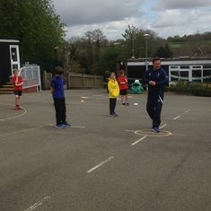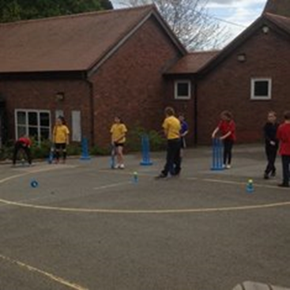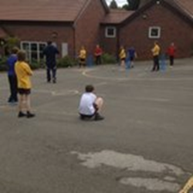

All of our children from years 4 and 5 had the opportunity to compete at a cricket festival at Corley cricket club. Everyone took part in 4 games of cricket and we were really pleased when our A team came 3rd place and our B team 4th place out of 14 teams!! Another great achievement!
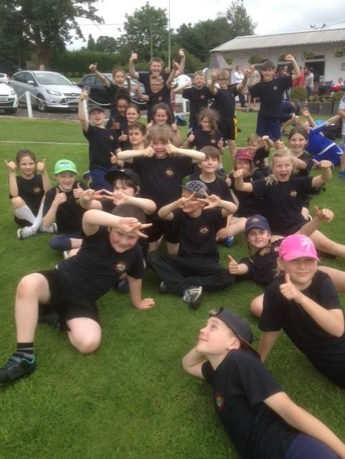
Our year 6 children also had the opportunity to visit Edgbaston Cricket Club for the day.....
We would also like to thank Fillongley Cricket club for sharing their coaching expertise with our younger children.

DANCE
We held our very own Strictly goes Bournebrook for children in Key Stage 2 who had been learning how to waltz! All children competed and we chose winners from a very talented bunch.
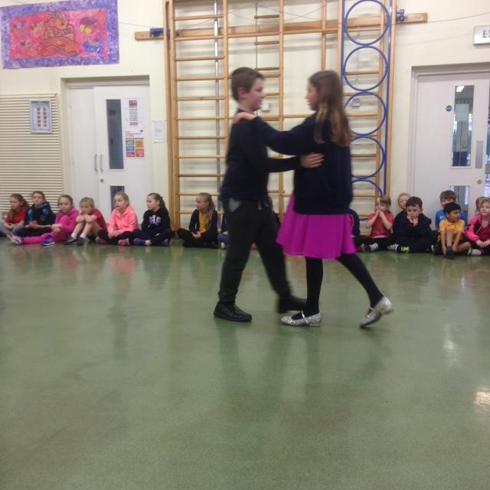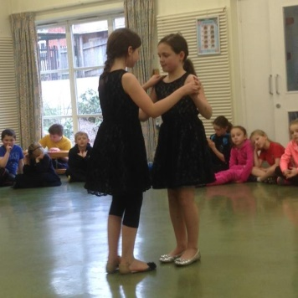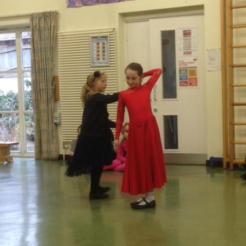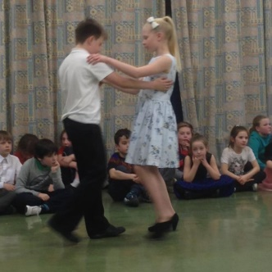

GYMNASTICS
10 children from year 1 and 2 competed in a level 3 county final in Solihull where they had to complete a set floor routine and a balance routine. This was the first time we had competed in a Gymnastics event but the children had such a wonderful experience that I’m sure it won’t be the last...
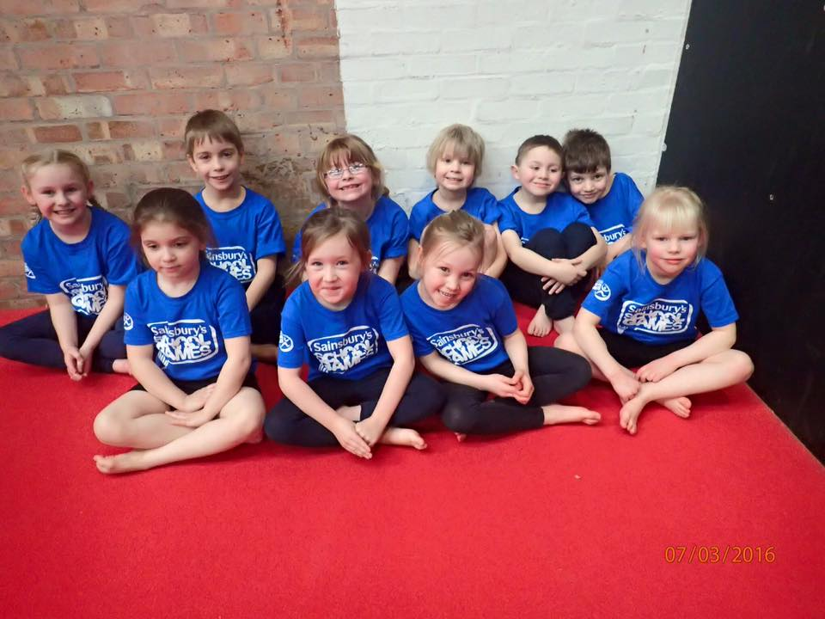

BIKEABILITY
11 of our Year 6 and 14 of our year 5 children completed their level 1 and level 2 courses to ensure they can ride their bikes confidently and safely.

SPORT FOR ALL
We took a team of children to the Pingles athletics track to take part in a range of activities... we got to try lots of different sports from archery to Boccia, curling, football, tennis and running and throwing. Our children proudly wore their gold medals back to school . Well done to all who participated.
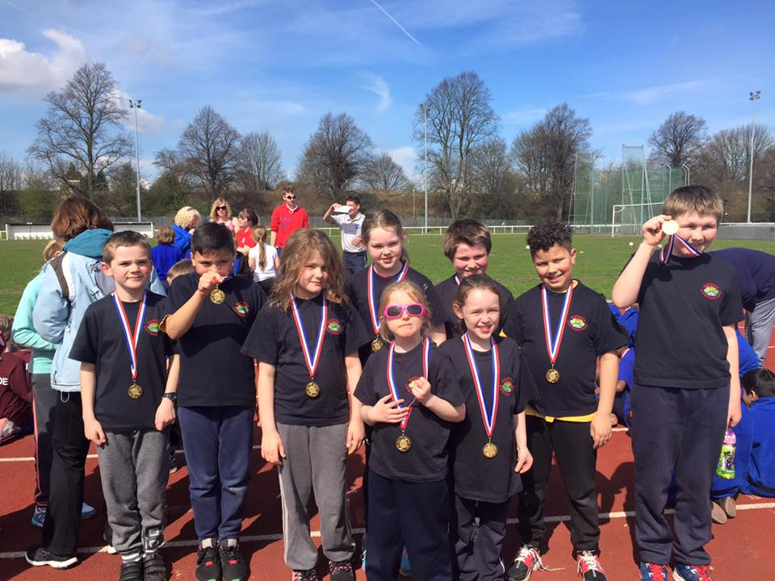

CHANGE FOR LIFE
At Bournebrook we are committed to ensure we educate our children for an active and healthy life style and many of our children have attended our change for life club run by Mr Mears during lunch times

Without the continued dedication of Mrs Cove and Mr Mears our children would not benefit from so many sporting opportunities.

This is just a summary of all we have achieved in sport this year. More details can be found on the School Sports Pages on our web site, on our Facebook page, in our Extra Curricular Sport and Physical Exercise display folder and on our Sports Board outside the hall.

