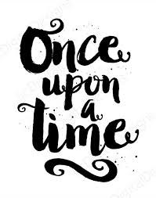

We are looking forward to celebrating WBD 2021 in school and with home learners on Thursday 4th March. We aim to foster a lifelong love of literature at Bournebrook and to support this, the following activities have been planned for the children, both at home and at school.

Miniature Books
All children are invited to make a miniature book on any topic – it could be a story or on a topic they are interested in, for example – Landing on Mars or Dancing. Instructions are on this link – children are invited to share a picture of their book on FB and also bring their tiny creations in to school when they all return to be put on display. https://www.bl.uk/childrens-books/activities/make-a-miniature-book#

Guess who’s reading competition – (£1.00 entry to go towards school fund). Children can have a go at guessing the teachers reading! Pay via parentpay – all correct entries will go in a lucky dip for a prize!

Special Story Times
Classes will be invited to watch specially selected storytime videos for them on their Teams page.

*****Dress as a book character
We know you all love this and so will do this later on in the year when everyone is here.

We hope your child enjoys all of the planned activities. Don’t forget, children will also be receiving a £1.00 book token.

